NAME:GOWTHAM REDDY
REG NO.: 192572066

Question 1 – RECTANGLE
Question:
Write a C++ program to create a class for a rectangle with a constructor and a destructor.
Aim:
To write a C++ program to create a Rectangle class using a constructor to initialize length and width, calculate the area, and use a destructor to display a message when the object is destroyed.
Pseudocode:
- Start.
- Define a class named Rectangle.
- Declare length and width as data members.
- Define a constructor that receives length and width and initializes them.
- Display a constructor-called message.
- Define getArea() to return length × width.
- Define a destructor to display a destructor-called message.
- In main(), read length and width from the user.
- Create a Rectangle object using the entered values.
- Display the area of the rectangle.
- End.
C++ Program:
#include <iostream>
using namespace std;

class Rectangle {
double length;
double width;
public:
Rectangle(double l, double w) {
length = l;
width = w;
cout << "Constructor called: Rectangle created." << endl;
}
double getArea() {
return length * width;
}

~Rectangle() {
cout << "Destructor called: Rectangle destroyed." << endl;
}
};
int main() {
double l, w;
cout << "Enter length: ";
cin >> l;
cout << "Enter width: ";
cin >> w;
Rectangle rect(l, w);
cout << "Area of Rectangle: " << rect.getArea() << endl;
return 0;
}

Input:
Length = 12
Width = 9
Output:
Enter length: Enter width: Constructor called: Rectangle created.
Area of Rectangle: 108
Destructor called: Rectangle destroyed.
Given Screenshot / Result:

Question 1 – Rectangle
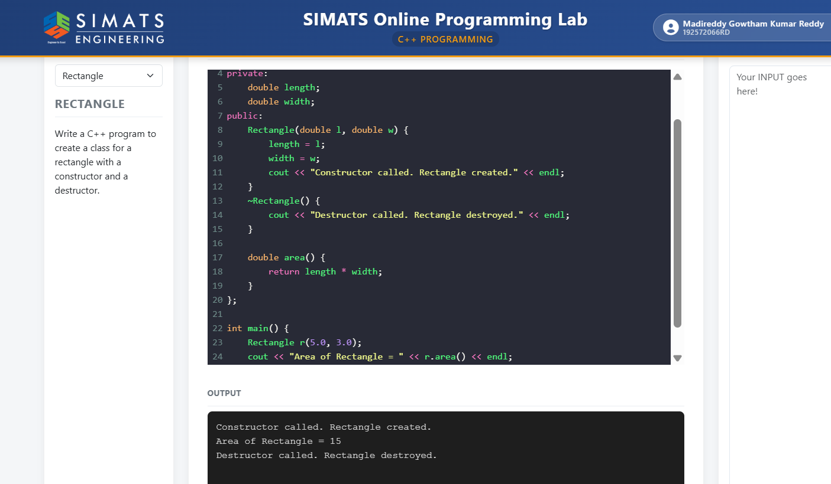
Question 2 – CAR
Question:
Write a C++ program to create a class for a car with a constructor and a destructor.
Aim:
To write a C++ program to create a Car class with a constructor that initializes the car brand and a destructor that displays a message when the car object is destroyed.
Pseudocode:
- Start.
- Define a class named Car.
- Declare brand as a string data member.
- Define a constructor that accepts the brand name.
- Assign the given brand to the brand data member.
- Display a constructor-called message.
- Define a destructor to display a destructor-called message.
- In main(), create a Car object with the brand "Toyota".
- End.
C++ Program:
#include <iostream>
using namespace std;
#include <string>

class Car {
public:
string brand;

Car(string b) {
brand = b;
cout << "Constructor called: Car " << brand << " created." << endl;
}

~Car() {
cout << "Destructor called: Car " << brand << " destroyed." << endl;
}
};

int main() {
Car myCar("Toyota");
return 0;
}

Input:
Brand = Toyota

Output:
Constructor called: Car Toyota created.
Destructor called: Car Toyota destroyed.
Given Screenshot / Result:

Question 2 – Car
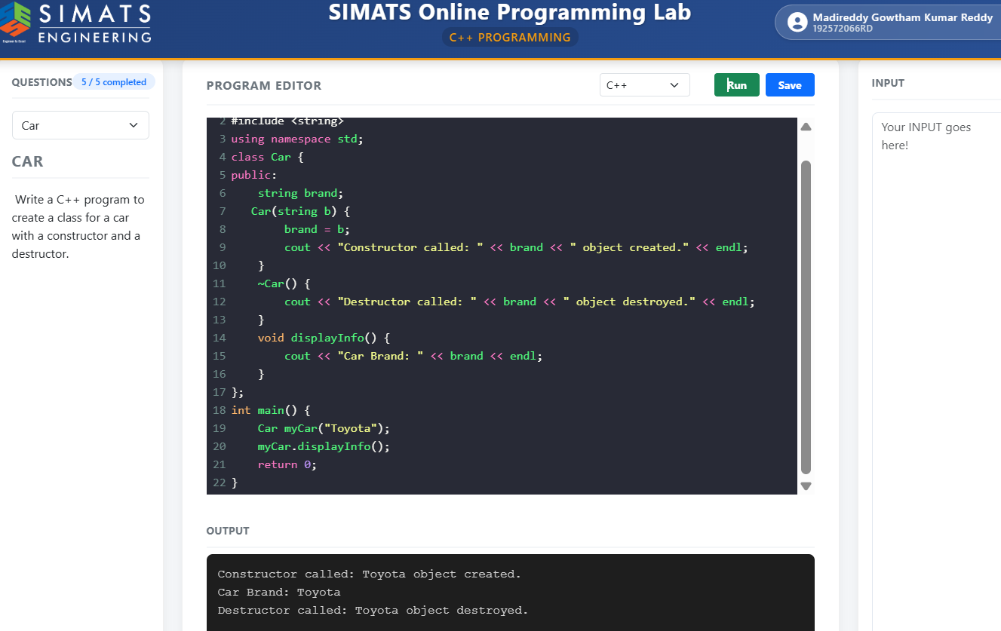

Question 3 – STUDENT
Question:
Write a C++ program to create a class for a student with a constructor and a destructor.
Aim:
To write a C++ program to create a Student class using a constructor to initialize student ID and name and a destructor to display the student details when the object is destroyed.
Pseudocode:
- Start.
- Define a class named Student.
- Declare id and name as data members.
- Define a constructor that accepts student ID and name.
- Initialize id and name using the constructor.
- Display a constructor-called message with student details.
- Define a destructor to display the student details.
- In main(), create a Student object with ID 192425258 and name "SHAIK ROSHAN".
- End.
C++ Program:
#include <iostream>
using namespace std;

class Student {
int id;
string name;

public:
Student(int i, const string& n) : id(i), name(n) {
cout << "Constructor called. ID: " << id
<< ", Name: " << name << endl;
}

~Student() {
cout << "Destructor called. ID: " << id
<< ", Name: " << name << endl;
}
};

int main() {
Student s(192425258, "SHAIK ROSHAN");
return 0;
}

Input:
Student ID = 192425258
Name = SHAIK ROSHAN

Output:
Constructor called. ID: 192425258, Name: SHAIK ROSHAN
Destructor called. ID: 192425258, Name: SHAIK ROSHAN

Given Screenshot / Result:
Question 3 – Student
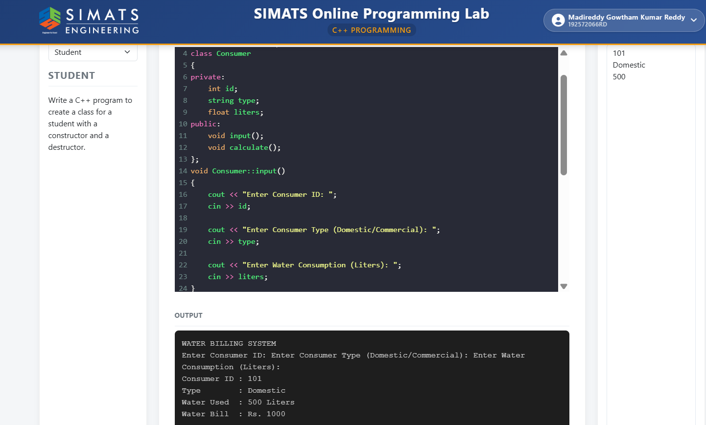

Question 4 – BOOK
Question:
Write a C++ program to create a class for a book with a constructor and a destructor.
Aim:
To write a C++ program to create a Book class using a constructor to initialize the book title and a destructor to display a message when the book object is destroyed.
Pseudocode:
- Start.
- Define a class named Book.
- Declare title as a private string data member.
- Define a constructor that accepts the book title and initializes title.
- Display a book-created message.
- Define a destructor to display a book-destroyed message.
- In main(), create a Book object with the title "C++ Programming".
- End.
C++ Program:
#include <string>
#include <iostream>
using namespace std;

class Book {
private:
string title;

public:
Book(const string& t) : title(t) {
cout << "Book created: " << title << endl;
}

~Book() {
cout << "Book destroyed: " << title << endl;
}
};

int main() {
Book b1("C++ Programming");
return 0;
}

Input:
Book title = C++ Programming
Output:
Book created: C++ Programming
Book destroyed: C++ Programming
Given Screenshot / Result:
Question 4 – Book
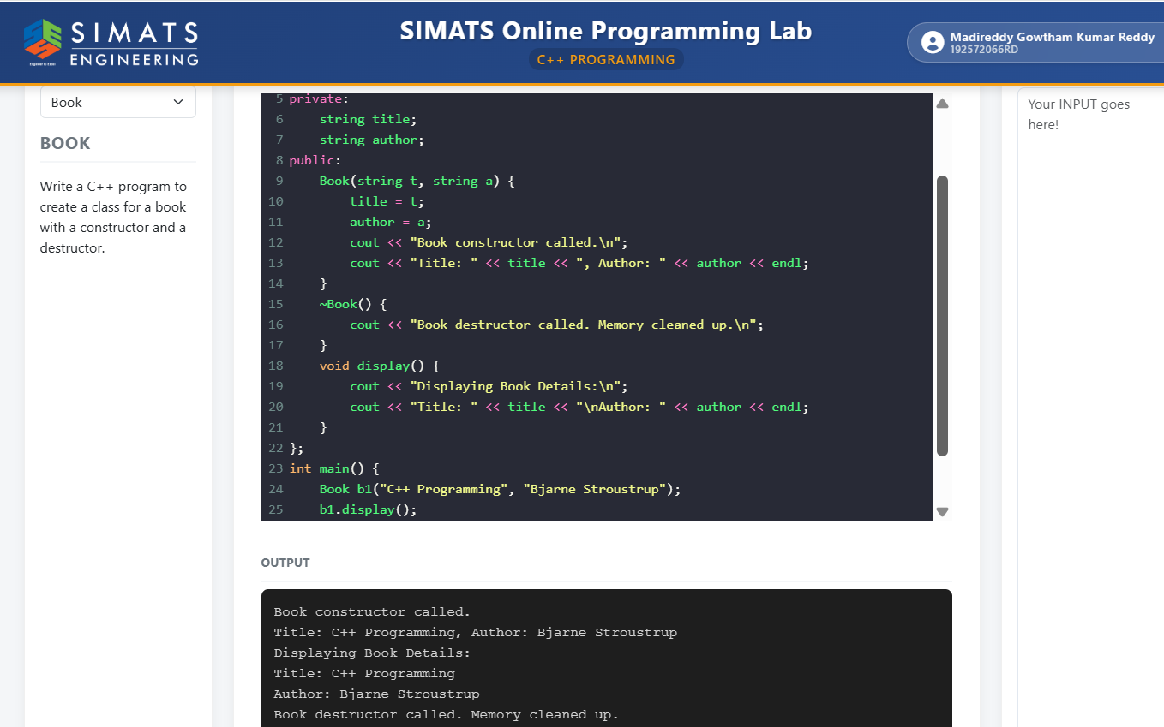

Question 5 – BANK ACCOUNT
Question:
Write a C++ program to create a class for a bank account with a constructor and a destructor.
Aim:
To write a C++ program to create a BankAccount class using a constructor to initialize the account holder and balance, display the balance, and use a destructor to display a closing message.
Pseudocode:
- Start.
- Define a class named BankAccount.
- Declare accountHolder and balance as data members.
- Define a constructor that accepts account holder name and initial balance.
- Initialize accountHolder and balance.
- Display the account-created message.
- Define a destructor to display the account-closing message.
- Define displayBalance() to show the account holder and current balance.
- In main(), create a BankAccount object for "SHAIK ROSHAN" with an initial balance of 1000.50.
- Call displayBalance().
- End.
C++ Program:
#include <iostream>
#include <string>
using namespace std;

class BankAccount {
string accountHolder;
double balance;

public:
BankAccount(string name, double initialBalance) {
accountHolder = name;
balance = initialBalance;
cout << "Account created for " << accountHolder
<< " with balance: $" << balance << endl;
}

~BankAccount() {
cout << "Closing account for " << accountHolder
<< ". Goodbye!" << endl;
}

void displayBalance() {
cout << "Account Holder: " << accountHolder
<< " | Current Balance: $" << balance << endl;
}
};

int main() {
BankAccount myAccount("SHAIK ROSHAN", 1000.50);
myAccount.displayBalance();
return 0;
}

Input:
Account Holder = SHAIK ROSHAN
Initial Balance = 1000.50
Output:
Account created for SHAIK ROSHAN with balance: $1000.5
Account Holder: SHAIK ROSHAN | Current Balance: $1000.5
Closing account for SHAIK ROSHAN. Goodbye!
Given Screenshot / Result:
Question 5 – Bank Account
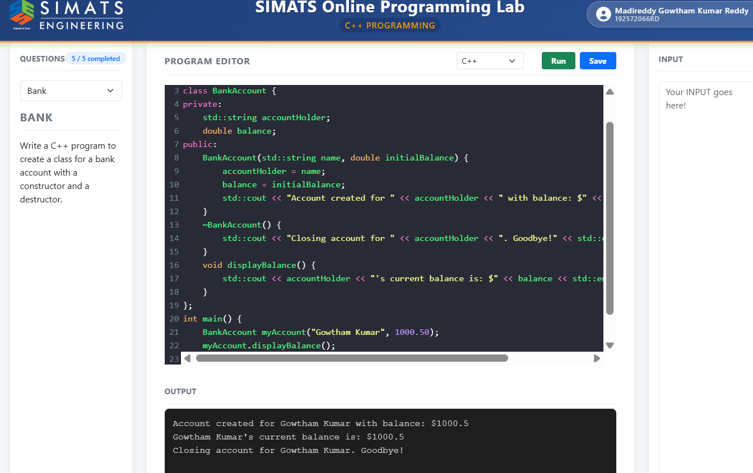
Conclusion
These five C++ programs demonstrate the use of classes, constructors and destructors. A constructor is automatically called when an object is created, while a destructor is automatically called when the object is destroyed. The programs also show how constructors can initialize object data and how destructors can be used to display cleanup messages.

